Ministry of Higher Education and Scientific Research
Hassiba Ben Bouali University of Chlef
Faculty of ForeignLanguages
Laboratory of information and communication technologies in the teaching of foreign languages ​​and translation
APON Team Organizes:
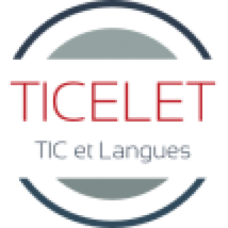
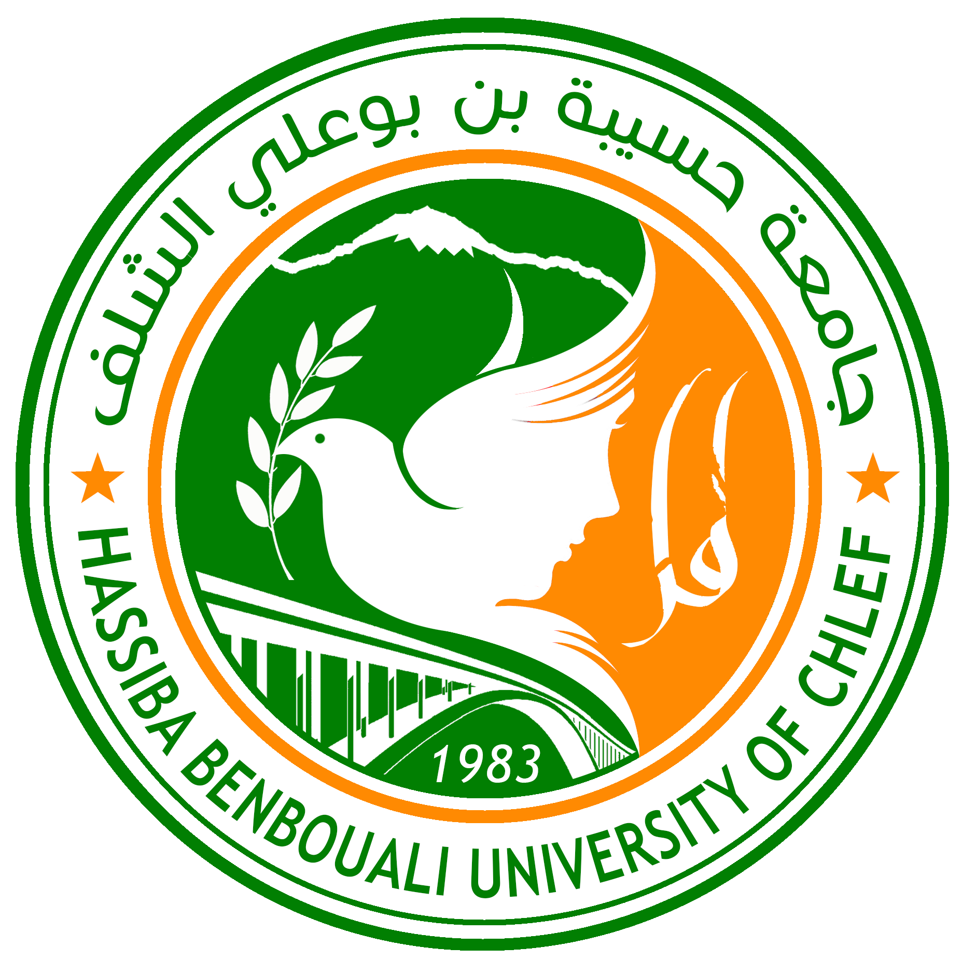

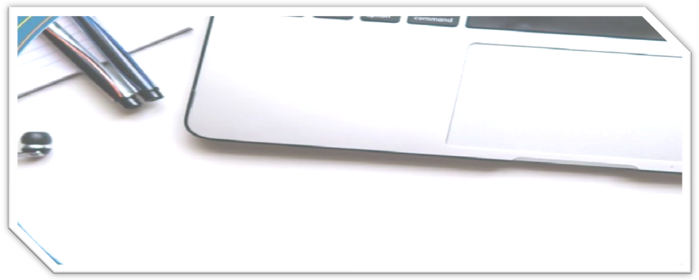

The International Online Conference on
Ubiquitous Learning for a Lifelong Quality Education:
A Vision for the Future
 Held on 13th & 14th of November 2022

Conference Program
First day,Sunday,November,13th, 2022

Opening Ceremony

Chair: Dr. Nacera BENALI REGUIEG

Technician : Dr. Nacera BENALI REGUIEG / Dr.MEHDI Tayeb
https://meet.google.com/hyv-uicv-tkd
08h40 - 09h10 | Verses from the Holy Quran  Algerian National Anthem  Rector of the University: Prof. Lakhdar GUERINE  Dean of the Faculty : Prof. Nouredddine DAHMANE  Laboratory president Dr.Faiza BOUKHELEF  Chair: Dr. Tayeb MEHDI / Dr. Sarah MEHARET
Plenary Session
Chair : Prof.L.Kara Mostefa- Boussena
Technician : Dr. Nacera BENALI REGUIEG / Dr.MEHDI Tayeb
https://meet.google.com/hyv-uicv-tkd
09h10-09h30 | Dr. Sadia BELKHIR .Metaphor teaching and online learning: Practical strategies. Tizi-Ouzou University. Algeria.
09h30-09h50 | Sc.Dir.Dr. Herbert Arlt; New technologies and Learning. Vienna.
09h50-10h10 | Dr. Islam BENADEL.Notes on Blended Learning in Higher Education: Cultural Perspective. University of Limerick.Ireland
10h10-10h30 | Dr. Josephine Remon; Co- Constructing Online Presence. University Lyon2. France.
10h30-10h50 | Ms.Ghizlane ZAOUI. Algerian ICT Vision: Its Present and Prospects . Newcastle University-England
10h50-11h10 | Dr.Miguel Roig; Strategies for Preventing Plagiarism. St. John's University. New York.USA
11h10-11h30 | DEBATE
Workshop N 01: Technology and Equality in Education
Chair : Dr. Benabdi Farouk
Technician : Dr. Nacera BENALI REGUIEG / Dr.MEHDI Tayeb (0774934834)
https://meet.google.com/hyv-uicv-tkd
11h30-11h40 | Dr. Benabdi Farouk; The Inculcation of Toleration within Algerian Universities Case of Study: The Teachers and Students of the Literature and Civilization Master (1st and 2nd Years), Department of English Language and Literature. University of Mascara.
11h40-11h50 | Ms. BOUCHRA BOUKHIAR; Equity or Equality for Down Syndrome Pupils in Algeria: Which Academic Program to Adopt?. Sidi Belabess University.
11h50-12h00 | Dr. Bekkar Miloud; Prospects of Teaching by Competencies at Algerian University: An Insight of the 1st Year LMD Level. Mascara University.
12h00-12h10 | Mr. KHADIR Fouad Soufiane; On-line Learning in Algerian Higher Education, a Panacea or a Filling Gap Policy? Sidi Belabess University.
12h10-12h20 | Mr. Ahmed Islam Belaifa; Equality in Higher Education: Revamping the Perception of Equality of Condition. Annaba University.
12h20-12h30 | Dr. Makhlouf Kouider; An Exploratory Analysis of Culture and Information Technology Transfer (IT) in the Arab World. University of Chlef.
12h30- 12h50 | DEBATE
12h50-14h00 | BREAK
Workshop N 02: Creative Teaching, Critical thinking and Lifelong Learning
Chair : Dr. Malika Zourgui
Technician : Dr. MEHDI Tayeb (0774934834) / MEHARET Enfel
https://meet.google.com/acn-pswa-zzm
14h00-14h10 |  | Dr. Malika Zourgui &Dr. Nacera Benali Reguieg ; Promoting Critical Thinking in Higher Education. The Case Study of Master Students at Hassiba Benbouali University. Chlef University
14h10-14h20 |  | Dr. Abderrazak BEDDIAF University Hybrid Education in Spain and Algeria: Post- First-Covid-19 Lockdown Teaching Experiences. Khenchela University
14h20-14h30 |  | Dr. IMERZOUKENE Sonia, Do ICT tools make teachers more or less creative in their classes?. University of Bejaia
14h30- 14h40 |  | Dr. AMEL MEBARKI; Using ICT in EFL Classrooms: Benefits, Drawbacks, Challenges and Attitudes. Ain Temouchent University
14h40- 14h50 |  | Miss.HADEF Chahida; Investigating the Use of Visual Aids as a Strategy to Create Critical Thinking and prepare active learners. Oran2 University.
14h50-15h00 |  | Dr. KIES Mohamed &Prof Nadia KIES; Adapting to the Transformation of Education: New Challenges for Teachers. University of Sidi Belabess.
15h00-15h10 |  | Dr. EL AGGOUNE Amina; Storytelling as a Creative Technique in EFL Classrooms. Guelma University.
15h10- 15h20 |  | Ms. Guellouma Rima. The Impact of Teachers’ Relationship on Novice Professional Development: The Case of Teachers in the Department of English, Blida2 University
15h20- 15h30 |  | Dr. Yamina ILES ; Virtual Learning and Classroom Learning in College Environment. Higher School of Management Tlemcen ESMT
15h30-15h-40 |  | Prof GRAZIB Mohamed ; The Efficiency of Online Corpora in Advanced Linguistic Studies. University of Saida
15h40- 16h00 |  | DEBATE
Workshop N 03: The Teaching of the four skills, Literature, civilization, Translation and ESP
Chair : Dr.Zahra BENALI FELLAGUE
Technician : Mr. CHERFA Farouq (0557023684)/ATTATEBI Ouail
https://meet.google.com/npc-jdcr-oam
14h00-14h10 |  | Dr. Faiza BOUKHELEF & Mrs. Ahlam SENNOUCI; Fostering Transformative Learning Process in Education: Literature as a Bridge to Increase Cultural Competence. Chlef University.
14h10-14h20 |  | Dr. Ahmed Mohammed Ahmed Moneus; Towards Using New Strategies in Teaching Literature Courses at Yemeni Universities. University of Sana’a.Yemen
14h20-14h30 |  | Dr. Amina Bouguessa & Dr. Khaldia Boughena; Shifting from Knowledge telling to knowledge transforming by means of Editorial acquisition. University of Tiaret.
14h30- 14h40 |  | Dr. Abdelkader Makhlouf & Dr. Abdelkrim Merahi; Students’ Perceptions of Teaching Translation between Qualitative and Quantitative Standards. Bayadh Univ& Saida Univ.
14h40- 14h50 |  | Dr. Asma NESBA; The Impact of the Teachers’ Pandemic –Related Technological Experiences on the Post-Corona Stage. El oued University
14h50-15h00 |  | Dr. Leila Hennaoui ; Technology Integration in Legal Education. Chlef University.
15h00-15h10 |  | Ms. Farah SEKKAL, The Use of Technology to Enhance the Oral Skill : Case of 1 st Year EFL Learners in Tlemcen University. University of Tlemcen
15h10- 15h20 |  | Ms. Boughouas Lemya; Perspectives about U-Learning in the Oral Expression Class: Facts and Fiction. University of Mila.
15h20- 15h30 |  | Dr Oudyarou Saadia &Prof. Yahiaoui Habib, Shaking Students’ Traditional Perspective towards History through the Use of the SAMR Method of Technology. University of Mascara
15h30-15h-40 |  | Dr. Nour el Houda KHELOUFI; Integrating Hybrid Teaching Practices in Writing. Constantine University.
15h40- 16h00 |  | DEBATE

Workshop N 04: New Technologies and Education (Digital Literacy)
Chair : Dr. IDDOU Naima
Technician : Dr. MAKHLOUF Kouider ( 0699991798 )/ BENHALIMA Abdelkarim
https://meet.google.com/bat-jsrb-zsq

14h00-14h10 | Prof.Dr Mostari Hind Amel. The Effect(s) of Information Communication Technologies (ICTs) and Social Media on the Teaching/Learning Process: Evidence from the Algerian EFL Class. Sidi Belabes University.
14h10-14h20 | Dr. KERMA Mokhtar; Creativity in the Classroom: Methods that Spark Learners’ Engagement. Oran 2 University
14h20-14h30 | Dr. Kamila AMMOUR; The Impact of EFL Students’ Linguistic Background on their Digital Literacy: The Algerian Case. Tizi Ouzou University.
14h30- 14h40 | Dr. Derouag Mounira. Digital Literacy Development in the Service of Lifelong Learning: Examining EFL Students’ Formal and Informal Sources of learning. Batna2 Univ
14h40- 14h50 | Dr. Layla Zourez. Technology as a Mediator between the Teacher and the Learner in Fostering Educational Interaction. Mila University.
14h50-15h00 | Dr. Imane FERSAOUI, Preparing Learners for Effective Lifelong Learning: A Psychological Perspective. ENS Bouzareah, Algiers
15h00-15h10 | Dr. Amaria FEHAIMA; Flipped Classroom : Issues and Future Outlook. Ain Temouchent University.
15h10- 15h20 | Bouguerra Amel; EFL Teachers’ Digital Literacy Required for the Integration of ICT’s into Classroom Instruction: The Case of M’sila Secondary School Teachers. Chlef University.
15h20- 15h30 | Dr. Saliha BELEULMI. Distance education via MOODLE platform in the Algerian university: Ambitions and Realities. University of Constantine 1.
15h30-15-40 | Mr. Abdelhadi Ahmed CHADLI; Teachers’ and Students’ Attitudes and Practices towards Blended Learning. The Case study of Hamidate Secondary School, Mecheria. Oran2 University
15h40- 16h00 | DEBATE

Workshop N 05: Technology integration
Chair : Dr. BENADDA Abdelouahid
Technician : Dr. Ibtissam BENTALEB/ Dr.MEHARET Sarah
https://meet.google.com/ygz-cdhf-ycc

14h00-14h10 | Dr. Ibtissam BENTALEB/ Hakima MOUMNA. Cultural Differences Hindering the Successful Integration of ICT into Algerian Higher. University of Chlef.
14h10-14h20 | Youssif omar, Integration of Technology in Learning English as a Foreign Language at the University of Benghazi Language Center (UOBLC). University of Benghazi, Lybia.
14h20-14h30 | Ms. Razika Tedjani, Developing Communication in English in a Digital Learning Environment: Perceptions and Attitudes. University of Biskra
14h30- 14h40 | Dr. BENADDA Abdelouahid & Dr. BOUGUENOUS Abdellah. Education in the Real World: Towards Achieving an Effective Digital Pedagogy and Breaking down Learning Barriers. University of Relizane.
14h40- 14h50 | Dr.Sid Ali Selama, Challenges of Learning ESP in a Blended Model: Students’ Perspectives. (Ecole Supérieure en Sciences Appliquées d’Alger)
14h50-15h00 | Dr. Benstaali Leila, Challenges for Successful Adoption of ICT in Crowded EFL Classes. University of Mostaganem.
15h00-15h10 | Dr. Athina BOUKHELOUF, The Impact of Google Classroom as a Digital Tool on EFL Students’ Achievement. University of Batna2.
15h10- 15h20 | Miss.BOUABDALLAH SARA & Dr. MEHDI Tayeb; Teachers’ Practices and Barriers to Technology Integration: Case of EFL teachers of Mohammed Lamine Debaghine Setif2. University. University of Chlef.
15h20- 15h30 | Dr. Makouf Soumia, Investigating Teachers’ Perceptions of Technology Integration in EFL Classrooms at the University of Oran2. ENS d’ Oran.
15h30-15-40 | Dr Amara Naimi and Dr. Bachir Yaqout; ICTS in Learning and Teaching English Language at Higher Education. University of Chlef and University of Khemis Miliana
15h40- 16h00 | DEBATE

End of the first day program

Second day, Monday,November,14th, 2022

Workshop N 01: Quality Education
Chair :Dr. Nawal Kadri
Technician : Dr. MAKHLOUF Kouider / Mr.SENDJASNI Ilyas
https://meet.google.com/eac-ftss-obx
09h00-09h10 |  | Dr Nawal Kadri; Teaching outside the box: a students’ perspective. University of Bejaia
09h10-09h20 |  | Ms. zemali Selma; Toward Innovative Postgraduate Research in 21st century: Gain of Time and Efforts Through The use Of Technology and Social Media for Data Collection. Oran2 University.
09h20-09h30 |  | Dr. BEMMOUSSAT Nabil Djawad & Prof. BEMMOUSSAT Smail; Correlates Conducive to Quality Education in English Language Education.Tlemcen University
09h30-09h40 |  | Mr. Sedik BENBALI &Mr. Ilyas SENDJASNI Critical Thinking: A Window to a Bright Future for a Lifelong Quality Education. University of Chlef.
09h40-09h50 |  | Ms. Soumia Aouaidjia; Self-Regulated Learning and Academic Adjustment to University: A Correlational Study. Annaba University.
09h50-10h00 |  | Dr. BOUTOUIL Sarra; The Salient Formula that puts the Mission in Motion: Qualitative Learning. University of Oran USTO.
10h00-10h10 |  | Dr. kellil Mountassar-Billah; Consequences of Integrating Information and Communication Technologies in the EFL Classroom. Khenchela University
10h.10-10h20 |  | Dr. SEKHRI Ouided; The Role of University Teachers in Putting Information Technology into Practice While Presenting their Courses: The Case of Teachers of First Year Master Degree. at the Department of Arts and the English Language, Constantine 1 University.
10h.20- 10h.30 |  | Dr. Bourouina El-hadj; Improving EFL Teachers Proficiency Using Information and Communication Technology (ICT), “The case of Middle School Teachers”. University of Chlef.
10h.30-10h.40 |  | Dr. Aissa Hanifi; Content based Instruction Role in Providing Quality Education: Potential and Expectations. . University of Chlef.
10h40-11h00 |  | DEBATE
Workshop N 02: Effective online Assessment and Evaluation Methodologies
Chair : Dr. BENAIRED Aissa
Technician : Dr. BOUKHELEF Faiza( 0558352299 ) / Mr.Benbali Sedik
https://meet.google.com/zxi-xmnw-tmq
09h00-09h10 | Dr. Hadi Kheira; Some Teaching Tips for Overcoming Challenges and conducting an Effective Online Assessment in Algerian Universities. University of Ain Temouchent.
09h10-09h20 | Dr. Ahmed Hichem GHEMBAZA; Attaining Objectivity in the Evaluation of EFL Learners’ Oral Production (Case study of 2 nd Year Students – University of Dr. Moulay Tahar – Saida –Algeria. Saida University
09h20-09h30 | Ms.Belmokhtar Khadidja ; Exploring Algerian EFL University Teachers’ Online Assessment Challenges. University of Tlemcen.
09h30-09h40 | Dr. Sara MOUSSEDEK, The Efficacy of E-feedback on Students’ Writing. Oran 2 University
09h40-09h50 | Dr. Guermi Nour El Houda ; Rethinking assessment and evaluation methodologies in Algerian universities. ENS Bousaada, M’sila.
09h50-10h00 | Dr. Awicha BENABDALLAH; Assessment Driven ESP Classroom: A Preliminary Tool to Identify the Learners’ Lacks. Higher School of Management, Tlemcen.
10h00-10h10 | Bedda Noureddine .Understanding and Encouraging the Use of ICTs in EFL Classes. Mascara University.
10h10-10h20 | Dr. BOUMEDIENE Houda. Enhancing Critical Thinking In Literature Reviews Writing Through Assessment Rubrics. Laghouat university
10h20-10h30 | Bekki Chaima; The challenges Faced by Supervisees in the Supervision Process: The Case of Master 2 Students in the English Department, University of Algiers.  University of Algiers.
10h30-10h40  10h40-11h00 | Dr. BARAKA ABDALLAH ;The Use of Social Networks to Bbost EFL Learners'Writing Skills through Peers Assessment. Mascara University.  DEBATE

Workshop N 03: Virtual Learning and Alternative Education
Chair :Dr. Sarah MEHARET
Technician : Dr. MEHDI Tayeb (0774934834 )/ BENHALIMA Abdelkarim
https://meet.google.com/fky-bnvm-rgg

09h00-09h10 | Prof. Boumediene BENRABAH, Exploring Future Implications of Ubiquitous E-learning:A New Digital Era in Education. University of Tlemcen
09h10-09h20 | Dr. Montasser Mohamed Abdelwahab Mahmoud, Virtual EFL Classes Created by Zoom on Blackboard; Case Study of Engineering Students at Imam Abdulrahman Bin Faisal University. Saudia Arabia.
09h20-09h30 | Dr. Chahrazed HAMZAOUI, Shaping the Future of Higher Education: Lessons Learnt from the Covid- 19 Crisis. University of Ain Temouchent.
09h30-09h40 | Mr. KAFI Khaled; Integrating ICTs into language teaching: The use of Google Drive to create online activities. University of Tiaret.
09h40-09h50 | Dr. Bader Faiza, Blended Learning, Pragmatic Solution or Pedagogic Innovation?. ENS Constantine
09h50-10h00 | Dr. Nawal Khelalfa; Consequences of Virtual Teaching and Learning in Algeria: Insights from the Tertiary-level English Teacher. University of Tebessa.
10h00-10h10 | Ms. Kenza SAOU & Dr. Chahira NASRI, From Face-to-Face to Self-Directed Learning: Models for Blended Synchronous and Asynchronous Online Course Delivery. Biskra University
10h.10-10h20 | Dr. Nacereddine Benabdallah, Perspectives of Virtual Exchange in Algerian EFL Instruction: Facing the Digital Divide. University of Souk Ahras
10h.20- 10h.30 | Mr. Walid BENNANI, Developing Learners’ Intercultural effectiveness through Intercultural Virtual Exchange. Case of Third Year Students of English at Sétif 2 University. Setif 2 University.
10h.30-10h.40 | Ms. Nachida Babchikh; EFL Teachers’ Resistance to the Implementation of Distant Learning in the Algerian Universities. University of Mascara
10h40-11h00 | DEBATE

Workshop N 04: Mobile Mediated Education/Ubiquitous Learning
Chair :Dr. DACA Imane
Technician : Mr.CHERFA Farouq (0557023684 ) /Mr.ELHIRECHE Abderrahmen
https://meet.google.com/npz-yotr-zcn
09h00-09h10 | Dr. DACA Imane; Ubiquitous Learning: From an advent of Technologies to a Rebirth of Pedagogies. University of Limerick
09h10-09h20 | Dr. Driss Mohamed Amine; The Role of Mobile-based Dictionaries (MBDs) in Translation Practicum: A Ubiquitous Learning Perspective for Students’ Empowerment. University of Mascara
09h20-09h30 | Dr. BENGHALEM Boualem and Dr. NASRI Kamal; Exploring the Effects of Mobile Devices Efficacy on EFL Learner Autonomy. University of Ain Temouchent & University of Saida
09h30-09h40 | Mrs. Belkhir Meryem; The Impact of Using Mobile as a Ubiquitous Technological Tool on EFL Learners . A Case Study. University of Khemis Miliana
09h40-09h50 | Dr. Djamila BENCHENNANE. ESP Master 1 Students’ Attitudes Towards Mobile Learning. University of Mascara.
09h50-10h00 | Miss. Keltoum Bettahar & Dr BRAIK Fethiya. Informal Professional Learning.Universityof Chlef
10h00-10h10 | Dr LAHIOUEL Azza; The Use of Electronic Dictionaries for Enhancing EFL Learning: A Gushing of Glossary. University of Annaba.
10h.10-10h20 | Dr.Fatima Zohra SEMAKDJI & Dr. Lamia ELMECHTA; Ubiquitous Education: Perceived Usefulness of Mobile Phones in EFL Teaching and Learning Settings. University of Constantine 1
10h.20- 10h.30 | Dr. ELAGGOUNE Abdelhak; Teaching Civilization to EFL Students via Educational Multimedia: An Experimental Method. University of Guelma.
10h.30-10h.40 | Dr. Hadj Henni Imane. ICT as a supplementary mode of education in teaching literature.University of Chlef .
10h40-11h00 | DEBATE

Workshop N 05: Critical Thinking
Chair :Dr. Amina Babou
Technician : Ms. NAHI Sarra (0656975978 ) / ATTATEBI Ouail
https://meet.google.com/arb-zfbf-erb
09h00-09h10 | Dr. TAYEB BOUAZID, Incorporating Critical Thinking Principles in EFL Learners’ Academic life. The Case of Master students. University of M’sila
09h10-09h20 | Prof. Yahiaoui Habib & Dr Oudyarou Saadia ; Cultivating and enhancing critical thinking in EFL classes: an Overview. University of Mascara.
09h20-09h30 | Ms. Bensalah Hiba; Embracing Critical Thinking as a 21 st Century Skill in the EFL Context. University of Tiaret.
09h30-09h40 | Dr. Amina Bouaziz; Critical Thinking Skills in History and Civilization Classes. University of Tebessa.
09h40-09h50 | Dr. Houda FADEL; Exploring EFL Teachers’ Attitudes towards the Role of Flipped Classrooms in the Development of Learners’ Critical Thinking Skills. Setif 2 university
09h50-10h00 | Dr. Amine AYADA; The Importance of Critical Thinking in Higher Education. Tiaret University
10h00-10h10 | Ms. Houa Larbes, Developing the Communicative Competence Through the Effective Implementation of Critical Thinking. Bejaia University
10h.10-10h20 | Dr. Amina Babou; Critical Thinking Skills in the EFL Classroom: Outside of the Box!. University of Chlef.
10h.20- 10h.30 | Ms. Hannache Meriem; The Use of Online Self-Reflection to Teach Writing: The Case of Second Year ENSC Students. ENS Constantine.
10h.30-10h.40 | Prof. DIB Mohammed ,Teaching English throughout Poems. Sushi Approach as a case to the Point. Mascara University
10h40-11h00 | Debate

Closing Ceremony
Chair: Dr. MEHARET Sarah
Technician : Dr. MEHDI Tayeb (0774934834 ) / BENHALIMA Abdelkarim
https://meet.google.com/fky-bnvm-rgg
11h00- 11h30 | Recommendations  Representative of the Participants  Rector of the University: Prof. Guerine Lakhdar  Dean: Prof. Nouredddine Dahmane  Chair: Dr. MEHDI Tayeb / Dr. MEHARET Sarra  Verses from the Holy Quran  End of the program

